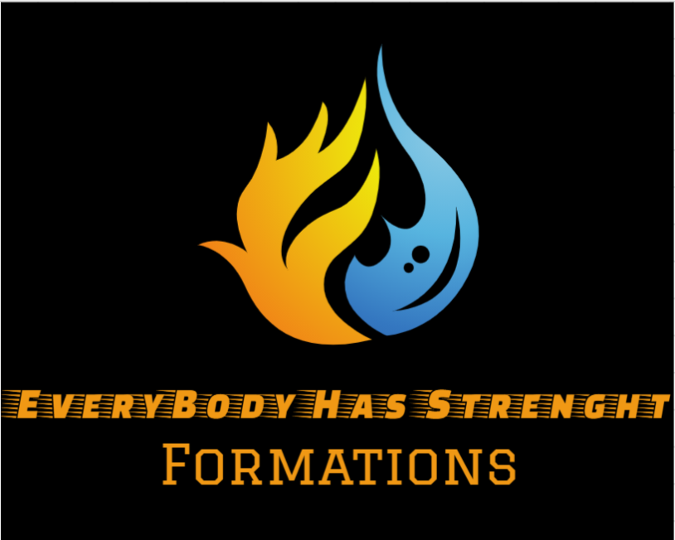

**EVERYBODY HAS**

**STRENGHT - Formations**

**PLEASE READ= before you read-this is a story on how the team was formed in the book of everybody has strength [the first part] the actions in the book are written in 1-1-1945 year so this is how the team was formed .**

One once apon a time two people of the Ninginton. {now believed as Australia}. there were studying elemental magic in the school of THE DARK OAK. After some years they finished the had graduated. They were SAMARTH A ,NISHANTH .they had to choose their elements :-

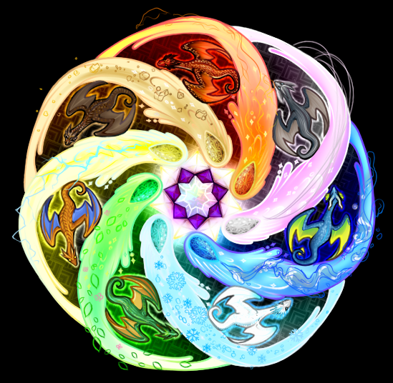

They had to choose from [ water, ice, fir, lighting, grass, darkness, earth]. but the strongest was the was the power of osmosis it a mixture of all it was. That is the power of osmosis. it is believed that only the greatest of the greatest people can enhance this power. The only person who has enhanced this power is juanliades is a an Indian he had studied in the university of?????? [ nobody knows where he studied]. after that samarth chose the element of fire, Nishanth chose the power of ice.

 

They began to explore at that time they had graduated for elemental school. Now they are in higher power school where they enhance their inner dragons. but it was not easy they were to be tamed by our own they only thought us about how they are and what are their powers, attacks. So, there they go to their journey the went to they went to the land of

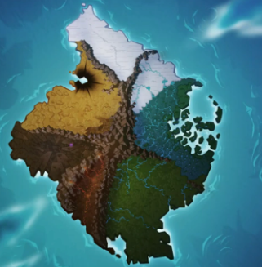 the dragon’s Nishanth went to the ice island and Samarth went to the fire island they found their dragons Samarth dragon was enormously powerful even Nishanth’s dragon.

 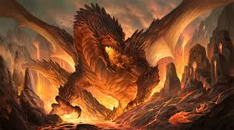 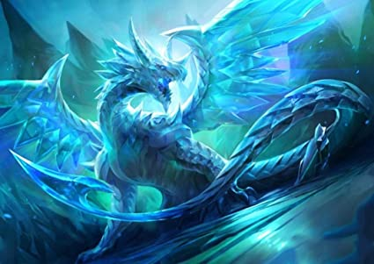

This was Samarth’s dragon on the other hand, Nishanth also found his dragon. His ice tail took Nishanth out. Samarth was also beaten up by his Dragon with fire blast. So, they both came back to mainland and built there houses they both wanted to live in the same house: -

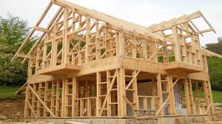

In some time, they were done with the model they had a lot of money because they were the topper of the class so when they graduated, they were awarded with 90,00,000$ each so they had a lot of money together they had 1,80,00,000 $ so the final product was amazing.

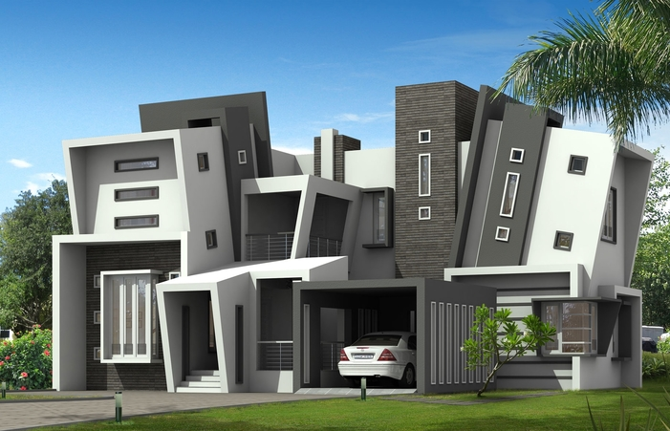

they needed a house because in the house they built it had a workshop, so they made ice and fireproof armor so there they go with their armor to the dragon’s island they tamed there dragons and enhanced there elemental swords

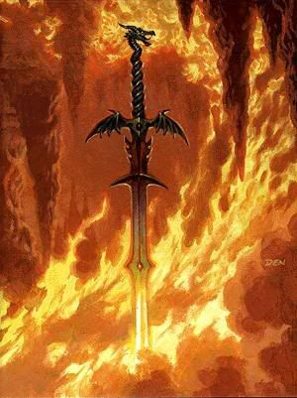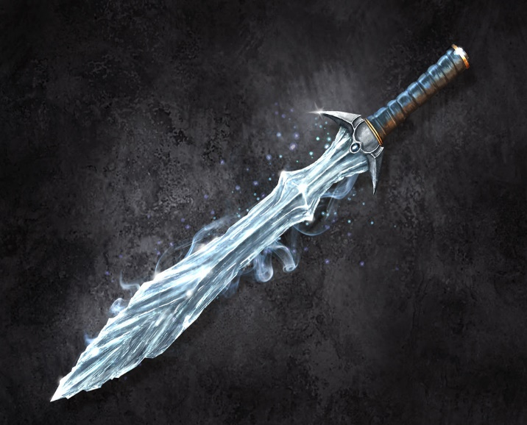

This was Samarth’s fire sword. | This is Nishanth’s ice sword.

So then when they returned home, they got a letter from there school. It was an elemental championship, but they needed a team of 8 people so then they thought to ask their childhood friends if they learnt elemental powers 6 of them told ‘YES’. They were.

1. Sakshi – elemental power {poison}
2. Pranav – elemental power {fighting}
3. Harshiil - elemental power {grass}
4. Samyak-elemental power {controls}
5. Minal – elemental power {wind}
6. Aromal-elemental power {lava}

But then they saw the rules of the championship was to flip a coin and who loses will have to face there weakness so if Samarth loses, he has to fight a water element which is his weakness but there were no rules to bring their dragons so they thought and asked the team if they have their elemental dragon the answer was “YES” so they lost all the coin flips but they beat up there opponent’s

with there Dragons.

THE NEXT PAGE IS ALL THE ELEMENTAL DRAGON

 

FIRE DRAGON ICE DRAGON

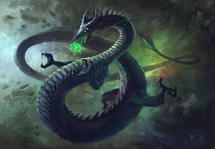 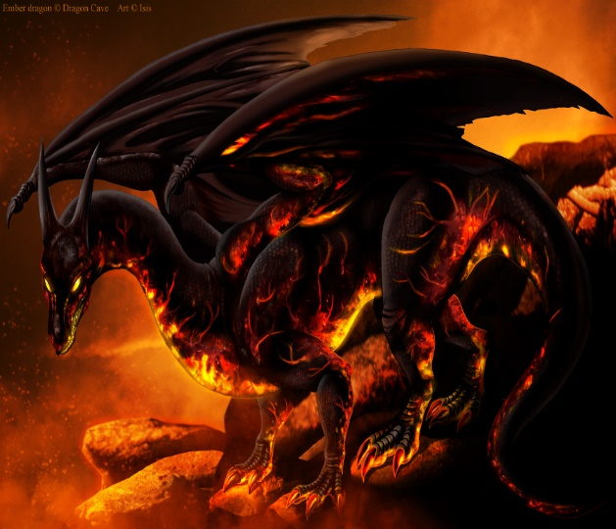

POISON DRAGON LAVA DRAGON

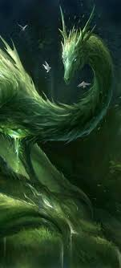 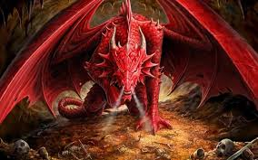

GRASS DRAGON FIGHTING DRAGON

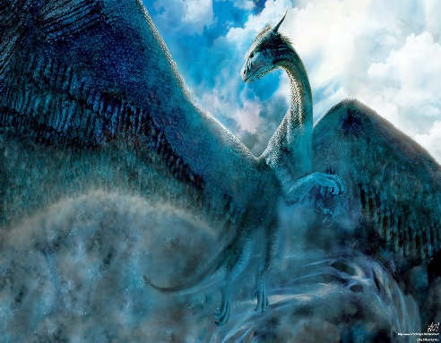 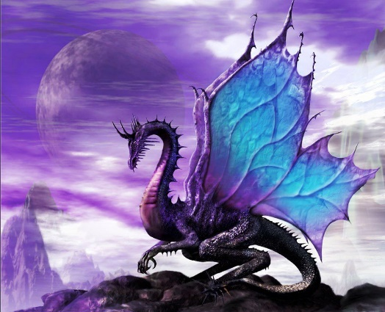

WIND DRAGON CONTROL DRAGON

They won the championship and then they won the special element

They had to chose between

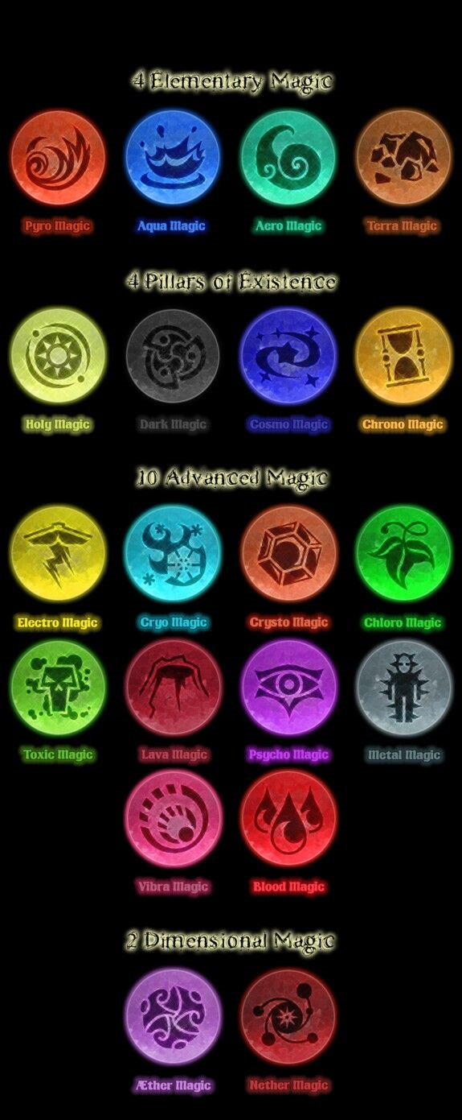

1. Sakshi – {Ather}
2. Pranav – {Blood Magic}
3. Harshiil - {holy}
4. Samyak- {chrono}
5. Minall –{Pyro}
6. Aromal- {Vibra}
7. Samarth- {Neather}
8. Nishanth- {Neather}

and now our hero’s go to the island of doom

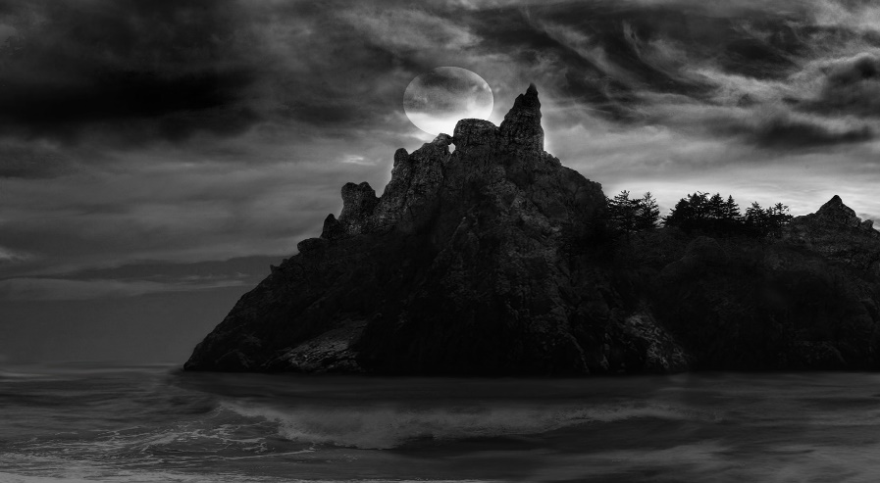

Thus, here they headed why no one knows it is believed that if anyone enters, they never come back. At the top of the island the tower of shadows. The only people who can enter the tower was the people who knew Neather Magic, so it was only of to Samarth and Nishanth. So, they reached by a boat, but they were tired to do their work. But they must stay quite in the night as there where rumours that there where big titans in the island at night so the must be careful, so Samarth suggested that we make a camp and stay. They could not do that ass the fire titan also know as Titanus Rodan. [Here is a picture of it]

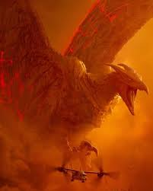 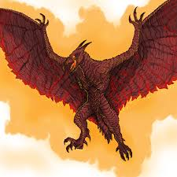

Rodan is a lot bigger than your fire dragon or any of our dragons so what do we do we have to do something?

And by the time the discussion was over it was morning so now what said Sakshi. Samarth told I have a special type of boots which do not make sound waves when we walk so, we do not attract the earth titan. They wore the boots. Heading towards the tower of shadows so they can retrieve the sword of osmosis and the golden armor it is said that the one with both the thing can control the titans. But they did not what to control the titans they wanted them to shift them into a different place so this island which is near there home can become a tourist place so Nishant and Samarth went into the tower there they saw there where 3 doors and all they had was Neather magic since the tower blocked the other elements each door had a symbol. It was dragon, titan and animal so they went for titan next was a bunch of tiles which looked as if the would fall if there is and ant on it and they had a clue the clue was what titans cant do so they thought of what titans can’t do they came to a conclusion of that a titan cant fail so they decided to just fall by stepping on the tiles and they fell the created a energy blob by the Neather magic and they landed safely and then the found a big path almost as it was never ending so they started walking on the path. On the other hand all the others had mistakenly stepped on a trip wire and triggered all the titans so they were running and running but the control titan can make normal people into mini titans so they were mostly hiding from him so they reached the end of the island now they knew that they would be dead as soon as the titans reached them they froze because Nishant and Samarth got the armor and sword so they where rescued and then they took the titans away from the island and put then in the place where only elemental masters can reach the hollow earth and the titan lived there and the armor and the sword where taken and they kept it in the boiling sea and so they opened an resort in the dark island and earned a lot by it and then the meet different element masters and formed an empire.



ABOUT THE AUTHOR

Name : Samarth A Telkar

Other books : Everybody has strength the first, Everybody has strength the kacha man ,the Legends of Dinosaurs

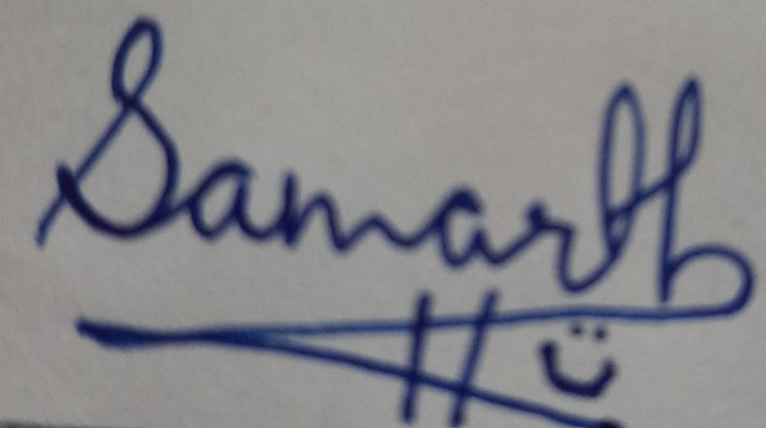

Signature of author